**Database Management and SQL Assignment Report.**

Tarandeep Singh (200514751)

Computer Studies, Georgian College

COMP 2003: Relational Database

Prof. Lyle Wood

October 09, 2023

Q1). Make a database and name it ‘Assignment2’ and add the data from Customers.sql to your database.

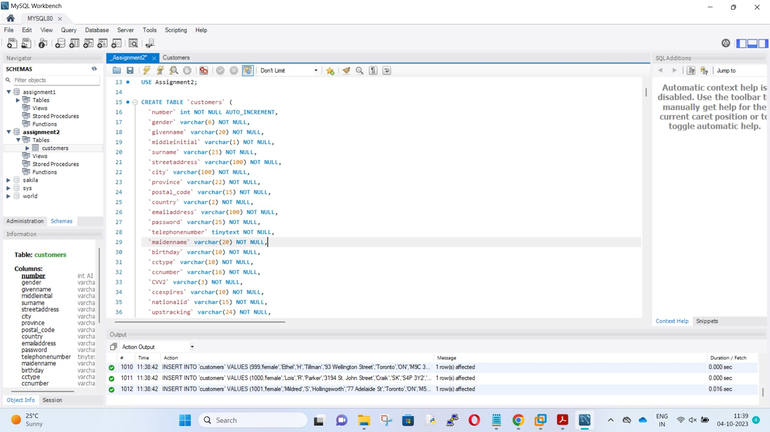

Q2). In your report, tell me what command you would use to generate a list of all the tables in your database.

Ans. SHOW TABLES; #basically it will list all data from the table and Describe the statement to return data from a table.

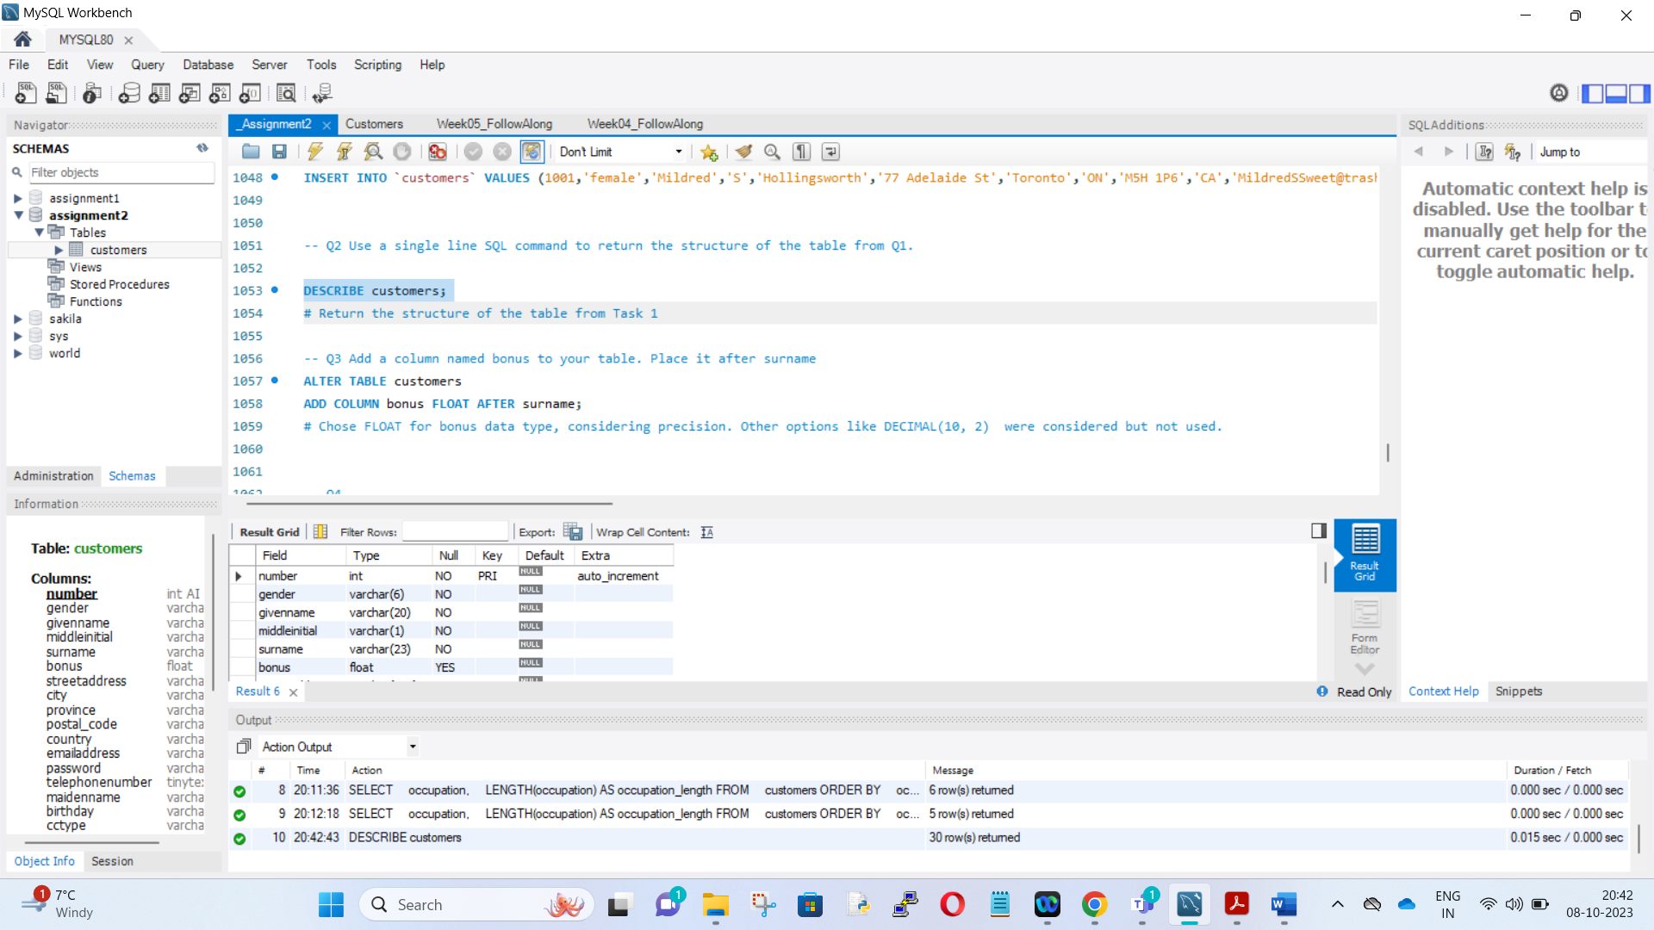

Q3). In your report, mention the data type you chose and another that you considered but chose not to use.

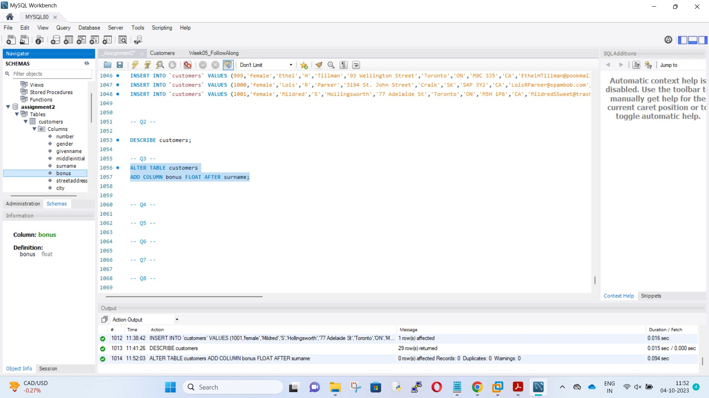

Ans. There are two data types which can be used here. Float and Decimal. Float is used in my assignment. Decimal can be used as well, in fact, it can give exact numbers like with decimal points.

Q4). Using a CASE command, fill in the bonus column's data. In your report, explain the considerations that were made in constructing this statement.

Ans Credit card type, location, and default bonus values were all taken into account..

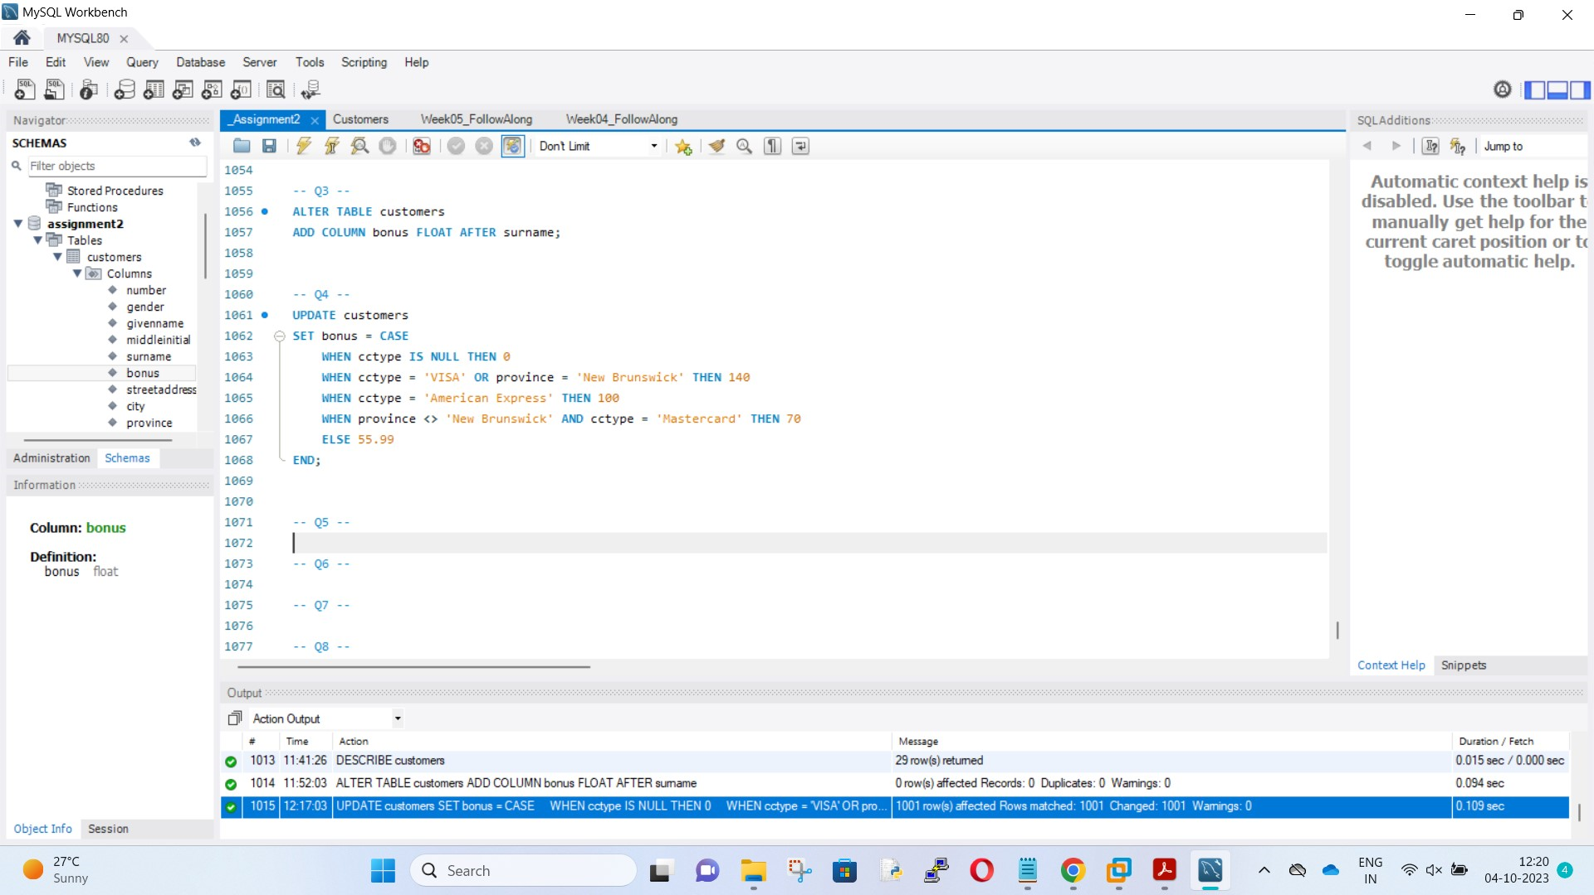

Q5). Let’s increase the bonuses. Please increase all the bonuses by 20% for customers who are born in August or work for the company Freedom Map. But, please only apply this increase to the people who were only getting a bonus of less than $140.

Ans. 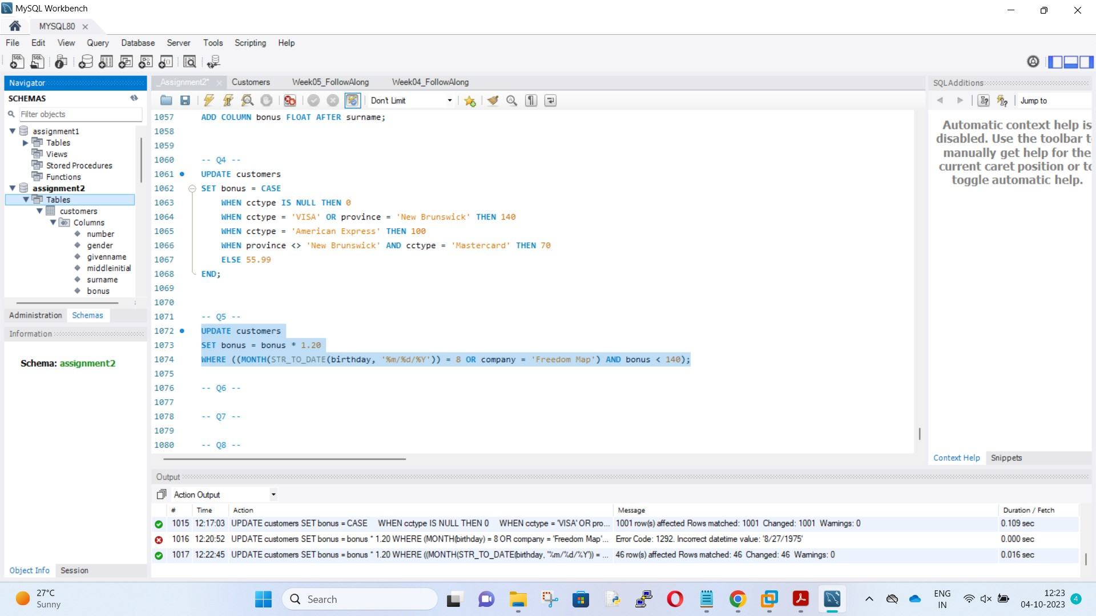

Q6) We need to calculate the total dollar value of bonuses being given to customers in each province. In your report, explain the considerations that were made in constructing this statement.

Ans. Consider grouping by province and calculating the average bonus value.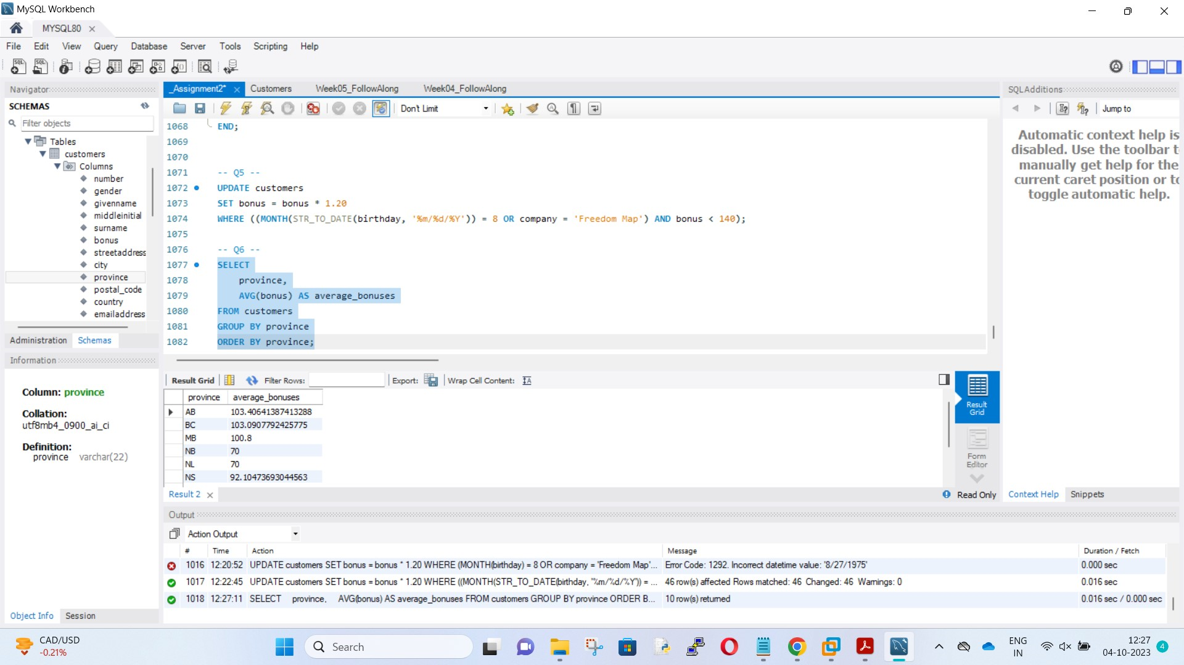

Q7). Generate a list displaying *only* the five longest occupations in the customers’ table.

Ans. We can use the LIMIT and OFFSET clauses for occupations from 6-10.

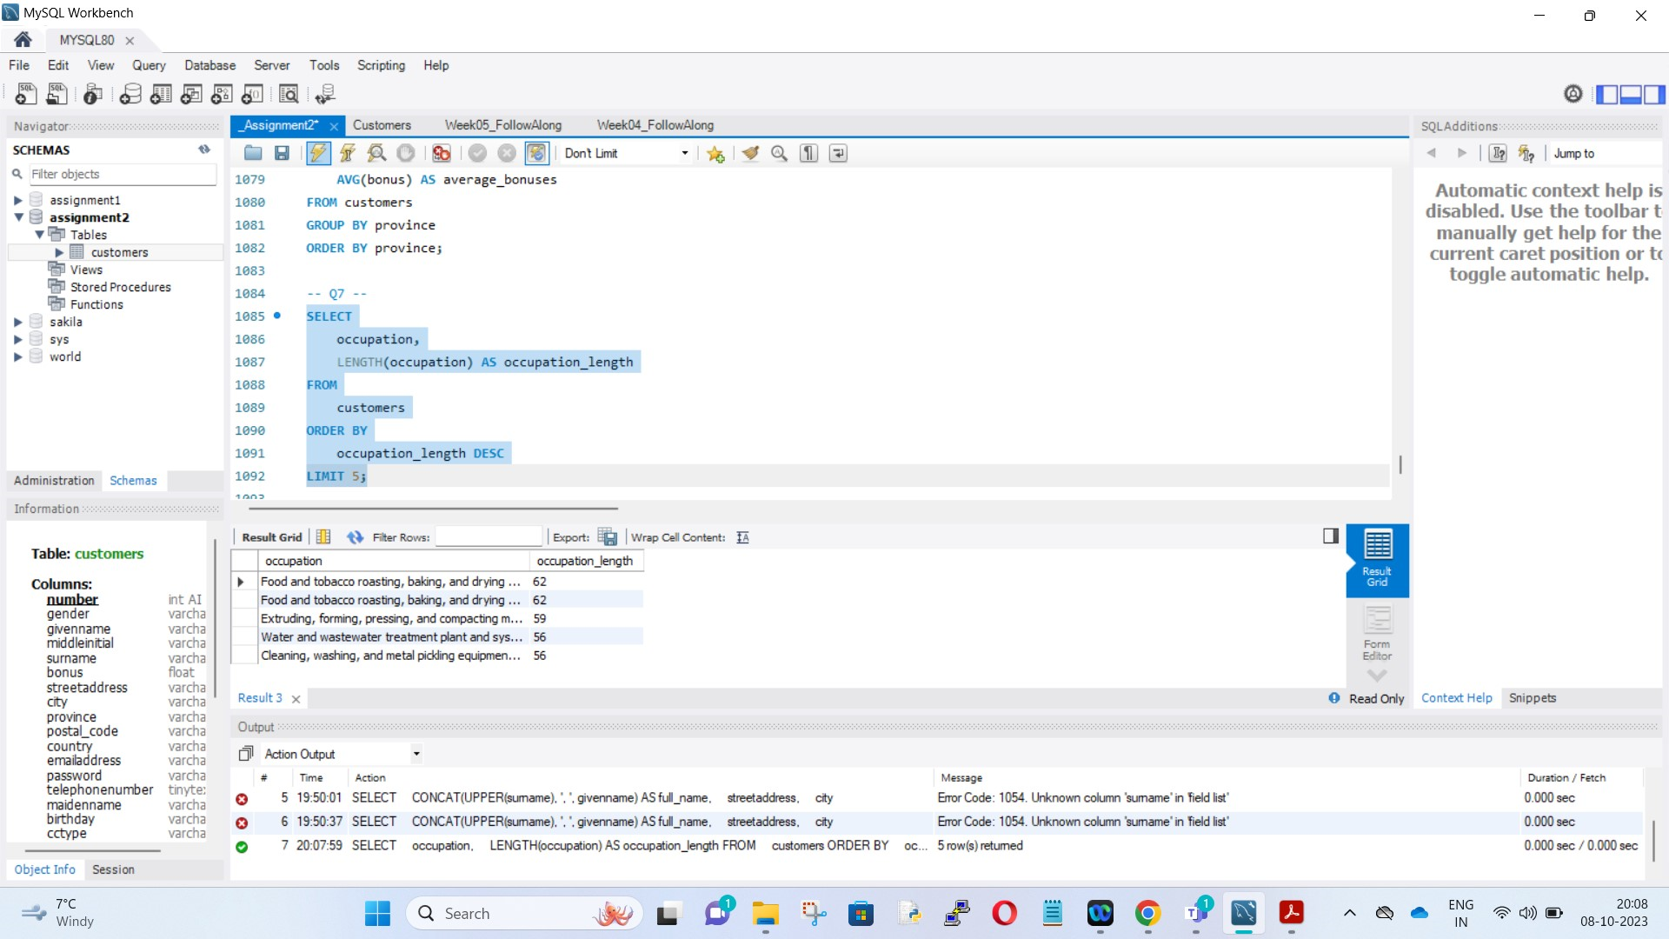

Q8). Write a query to show customers’ full names, street addresses, and cities.

Ans. 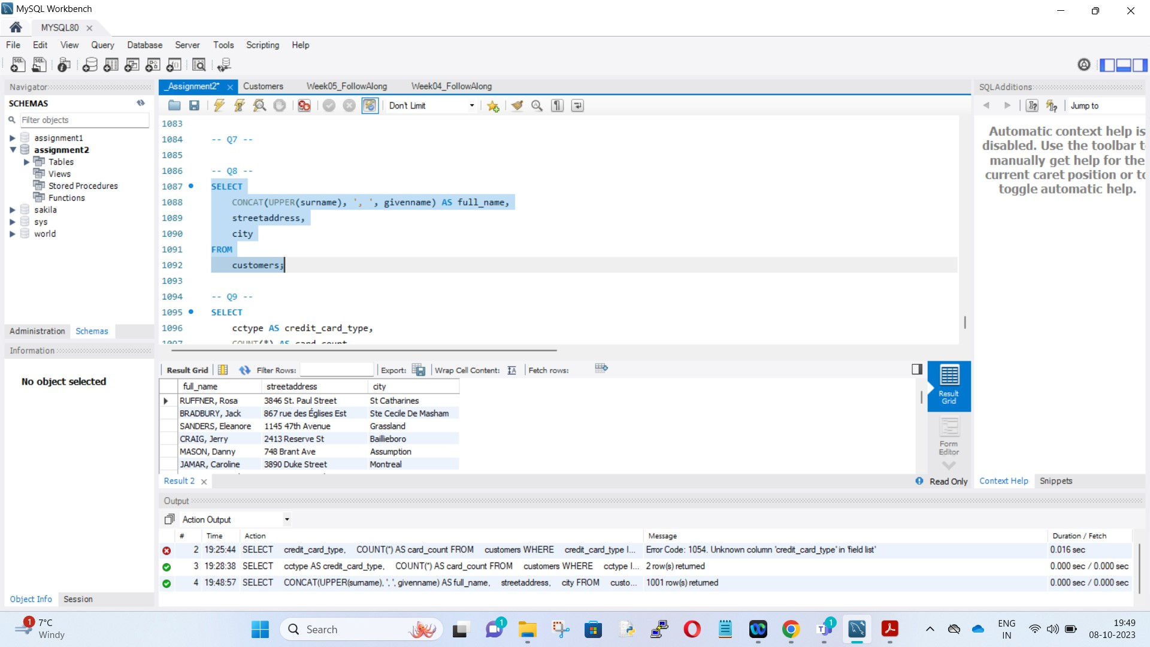

Q9). Write a query to show how many customers have Mastercard’s and how many are using Visa.

Ans. 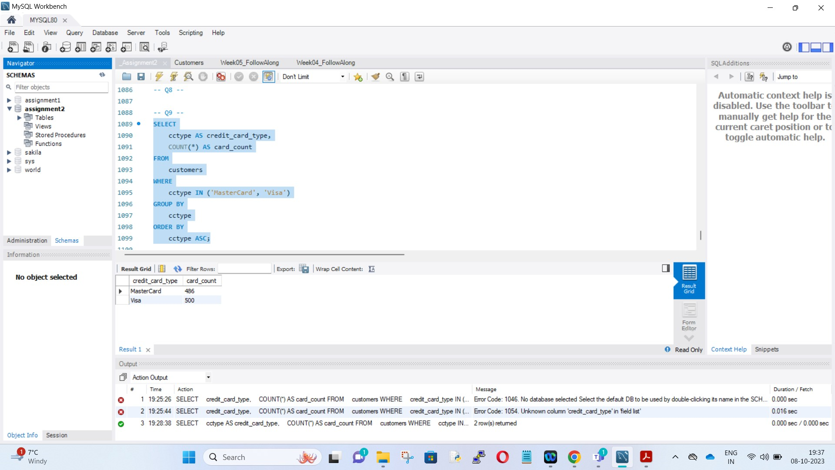

Q10). If you were asked to add a *total bonuses* column to the output results of Q9’s query tabulating the total bonuses provided to Visa vs MC customers, how would you do so?

Ans. It can be done by creating a sub-column under the bonus column.